Chart 1 (<https://stackoverflow.blog/2017/10/10/impressive-growth-r/>)

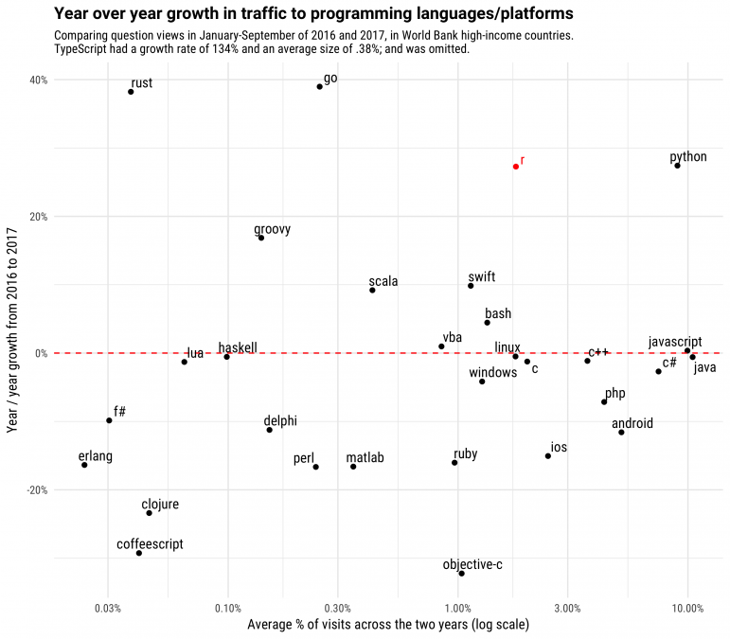

Chart 2 (<https://stackoverflow.blog/2017/10/10/impressive-growth-r/>)

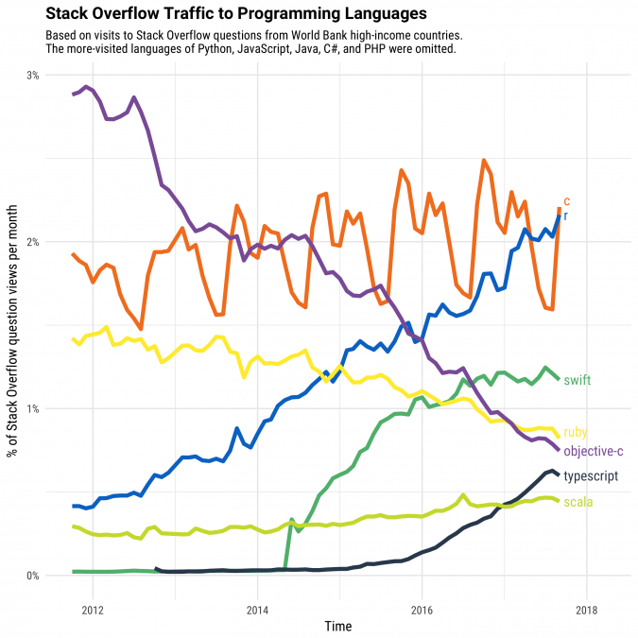

Table 1: (<https://www.tiobe.come/tiobe-index>)

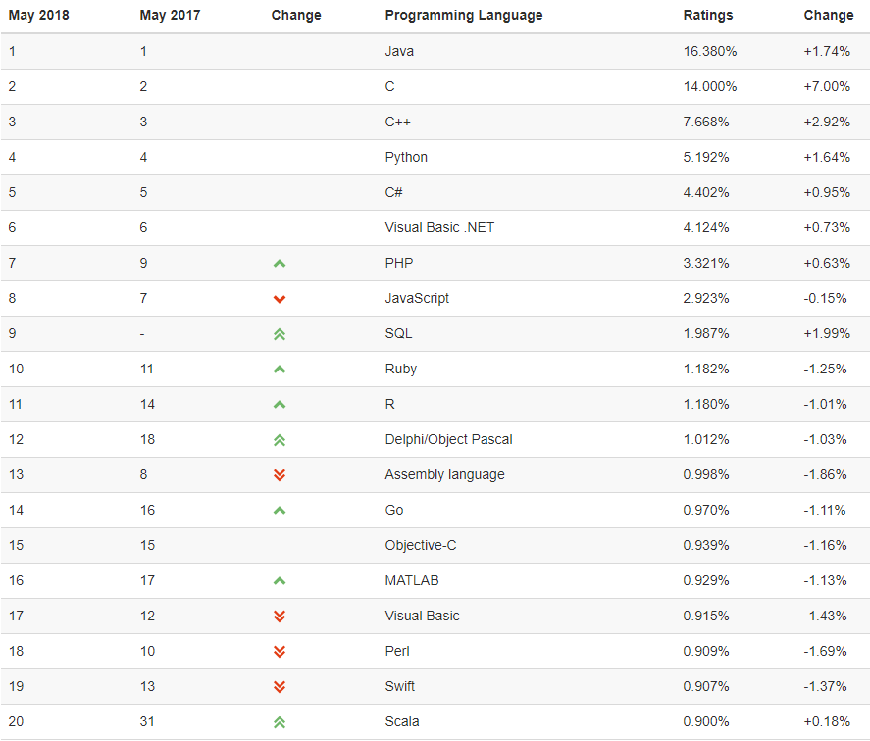

|  |  |  |  |  |  |  |  |  |  |  |  |  |  |  |
| --- | --- | --- | --- | --- | --- | --- | --- | --- | --- | --- | --- | --- | --- | --- |
|  | |  | |  | | **Source** (see following table) | | | | | | | | |
|  | |  | | **N** | **1** | **2** | **3** | **4** | **5** | **6** | **7** | **8** | **9** |
| Governance | | Organization structure of data assets | | 3 | Data silos |  | Politics |  |  |  |  | Lack of access to data  Big data silos or vendor owned data  The data science team competes with other departments | Departmental thinking rather than looking at the big picture |
|  | | Organisation: structure of data skills | | 1 |  | Analytics capabilities are isolated from the business, resulting an ineffective analytics organization structure |  |  |  |  |  |  |  |
|  | | No clear data strategy | | 11 | Lack of analytics strategy | Exec team doesn’t have clear vision for its advanced analytics programs  No analytics strategy beyond a few use cases |  |  | Trying to graft Big Data practices onto existing infrastructure and cultures | Starting with the data instead of the question |  | Lack of agreement on enterprise strategy  Problem avoidance  Allowing company bias to form conclusions before the data scientists start | Failing to build the need for big data within the organization  Islands of analytics with ‘Excel culture’  Lack of vision and not having a strategy; not having a clear organizational communications plan  Failure to re-organise for big data  Lack of vision and not having a strategy; not having a clear organizational communications plan |
|  | | The Big Bang strategy | | 3 | Big bang approach to transformation | Costly data cleansing efforts are started en mass |  | Overly long project timeframes |  |  |  |  |  |
|  | | No understanding of Big Data strategy | | 1 |  |  |  |  |  |  |  |  | Considering this as a one-time implementation rather than a living eco-system |
|  | | Planning: No clear goals | | 7 |  | No one determined the value that the initial use cases can delivery in the first year | Lack of a business use case |  |  | An exploratory approach to analytics instead of testing hypotheses  Weak hypotheses |  | Starting with the wrong question  Not addressing the root cause just trying to improve the effect of a process  Trying to take on too large a first project |  |
|  | | Planning: No support | | 6 |  |  |  | Lack of executive support  Lack of business support |  | Unengaged or absent stakeholders | Project champion | Weak stakeholder buy-in | Ignoring the need to sell success and market the big data program |
|  | | Planning: No voice of data | | 1 |  |  |  |  |  |  |  | Data scientists aren’t give a voice |  |
| Data quality | |  | | 7 | Data quality issues |  |  | Bad data |  | Inaccessible or bad data | Data quality | Using faulty/bad data  Manually classifying data | Data quality and reliability issues |
| Modelling | |  | | 1 |  |  |  |  |  |  |  |  | Not establishing company ontology and definitions for ‘single version of truth’ culture |
| Program Mgt | | Overburdened management | | 1 |  |  |  | Too many KPIs |  |  |  |  |  |
|  | | Not gathering requirements | | 1 |  |  |  | No methodology for gathering requirements |  |  |  |  |  |
|  | | Documentation | | 1 |  |  |  |  |  |  |  | Failing to document |  |
| Data skills | | Lack of suifficient skills | | 7 |  | Analytics roles – present and future – are poorly defined  Organization lacks analytics translators | Shortage of skills |  |  |  | Lack of resources | Poorly assessing a team’s skills and knowledge of data science tools  Lacking an experienced data science leader  Hiring scientists with limited business understanding |  |
|  | | No business focus | | 3 |  |  |  | Lack of skills to interpret the results |  |  |  | Fail to provide actionable insights and opinions  Lack of SMEs |  |
| Failures of outcomes | | Unrealistic expectations | | 5 | Unrealistic expectations about predictive results |  | Unreasonable expectations |  |  |  | Setting realistic goals | A boss read one of our blogs posts and now thinks he can solve world hunger  If you failed to plan, plan to fail |  |
|  | | No ROI on outcome | | 3 |  | Nobody knows the quantitative impact that the analytics is providing |  | No upfront definition of true ROI |  |  |  | Failing to communicate the value of the data science project |  |
|  | | Outcomes: lack of planning | | 2 |  | No focus on potential ethical, social, regulatory implications |  |  |  |  |  |  | Lack of upfront planning; overlooking the development of governance and program oversight |
|  | | User acceptance | | 6 |  |  |  | Bad user experience  Lack of user adoption |  |  | User adoption | Solutions are too complex  Data science team hasn’t built trust with stakeholders | Not establishing a formal training program |
| Analytics/DS | | Poor analysis | | 1 |  |  |  |  |  |  |  | Poorly designed models that are not robust or maintainable |  |
|  | | Poor data science | | 1 |  |  |  |  |  |  |  | Lack of standardized data science process |  |
| Technology | | Technology: wrong infrastructure | | 2 | Data warehouses that are difficult to manage; slow & costly to create | Analytics platforms aren’t built to purpose |  |  |  |  |  |  |  |
|  | | Wrong architecture | | 3 |  |  |  |  |  |  |  | Relying on Excel as main data storage  Having Data Scientist build their own ETLs | Not having the adequate architecture for data integration |
|  | | Old technologies | | 3 |  |  |  | Old technology |  |  |  | Poor choice of tools | Forgetting rapidly increasing complexities with …volume, velocity, variety, veracity, and many more |

|  |  |  |
| --- | --- | --- |
| 1 | 8 reasons why so many analytics projects fail | https://dzone.com/articles/8-reasons-why-so-many-analytics-projects-fail |
| 2 | Ten red flags signaling your analytics program will fail | https://www.mckinsey.com/business-functions/mckinsey-analytics/our-insights/ten-red-flags-signaling-your-analytics-program-will-fail |
| 3 | 4 reasons why big data analyistics projects fail, or do they? | mckinsey.com/business-functions/mckinsey-analytics/our-insights/ten-red-flags-signaling-your-analytics-program-will-fail?cid=eml-app |
| 4 | 11 Reasons Why Most Business Intelligence Projects Fail | https://channels.theinnovationenterprise.com/articles/11-reasons-why-most-business-intelligence-projects-fail |
| 5 | 85% of big data projects fail, but your developers can help yours succeed | https://www.techrepublic.com/article/85-of-big-data-projects-fail-but-your-developers-can-help-yours-succeed/ |
| 6 | Top 5 Reasons Why Analytics Projects Fail | https://www.forbes.com/sites/piyankajain/2015/12/12/5-reasons-why-analytics-projects-fail/#627a524f6507 |
| 7 | Top 5 reasons why your data analytics project isn’t meeting your expectations | https://www.swc.com/blog/business-intelligence/reasons-data-analytics-project-isnt-meeting-expectations |
| 8 | Top 32 reasons Data Science projects and Teams fail | http://www.acheronanalytics.com/acheron-blog/top-32-reasons-data-science-projects-fail |
| 9 | The Data Economy: Why do so many analytics projects fail? | http://analytics-magazine.org/the-data-economy-why-do-so-many-analytics-projects-fail/ |

A year ago, Gartner estimated that 60% of big data projects fail. As bad as that sounds, the reality is actually worse. [According to Gartner analyst Nick Heudecker](https://twitter.com/nheudecker/status/928720268662530048)‏ this week, Gartner was "too conservative" with its 60% estimate. The real failure rate? "[C]loser to 85 percent." In other words, abandon hope all ye who enter here, especially because "[T]he problem isn't technology," Heudecker said. It's you.

*Personal Google search (22/23 May)*

|  |  |  |
| --- | --- | --- |
| **Term** |  | **Returns (106)** |
| Business analytics |  | 674 |
| Business “data governance” |  | 2.9 |
| Business data architecture |  | 1.5 |
| Data “business intelligence” |  | 52 |
| Business “data analysis” |  | 71 |
| Data warehouse |  | 11.5 |
| Big Data |  | 77 |

(https://ai2-s2-public.s3.amazonaws.com/figures/2017-08-08/a8cb17a6f21c5c43359f52b07617faa92d3ef1d1/2-Figure1-1.png)

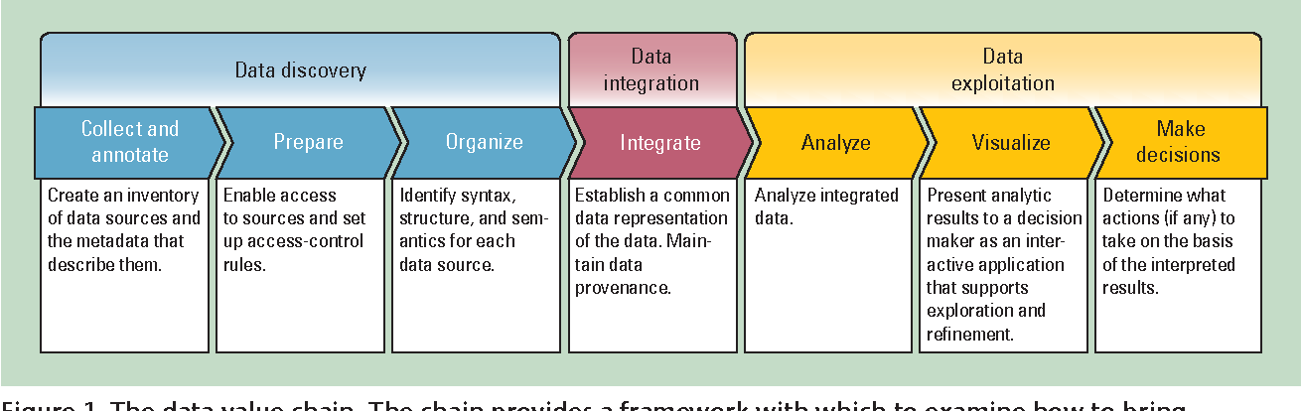

(From Data to Decisions: A Value Chain for Big Data

By: H. Gilbert Miller, Peter Mork

Published: 2013, IT Professional)

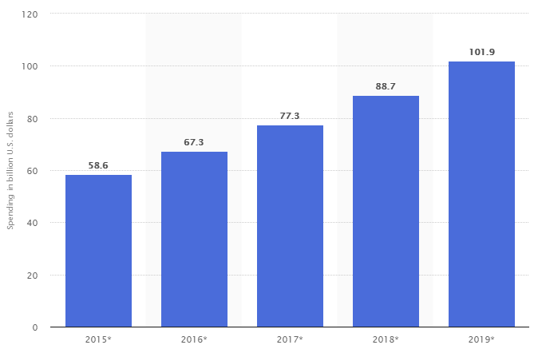

(<https://www.statista.com/statistics/490731/business-analytics-spending-worldwide/>)

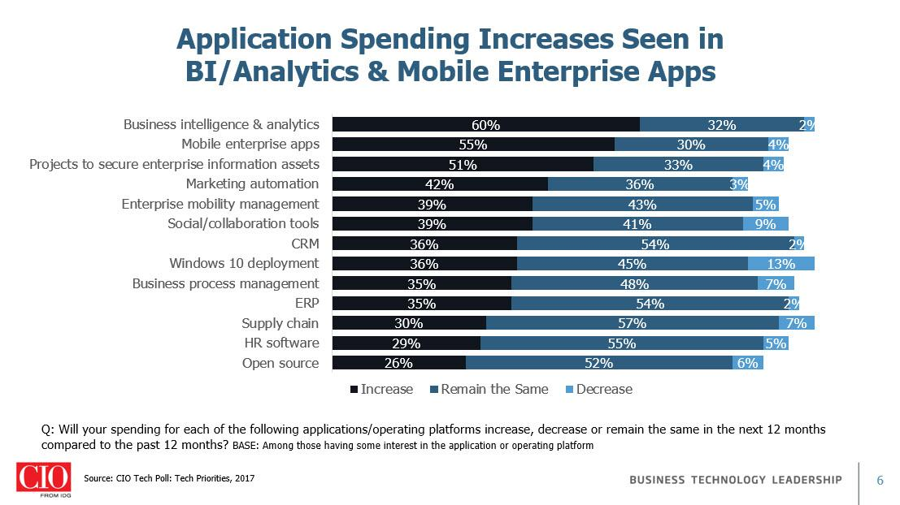

(<https://blogs-images.forbes.com/louiscolumbus/files/2018/02/Application-Spending-Increases-Seen-in-BI-Analytics-Mobile-Enterprise-Apps.jpg>)

